

***DATA ENGINEERING***

***WEEK-02***

***TASK-04***

*Submitted to*

***Sir Muhammad Ahtisham***

*Submitted by*

***Aabra Malik***

***Creating, Altering & Deleting Database***

***Creating Database***

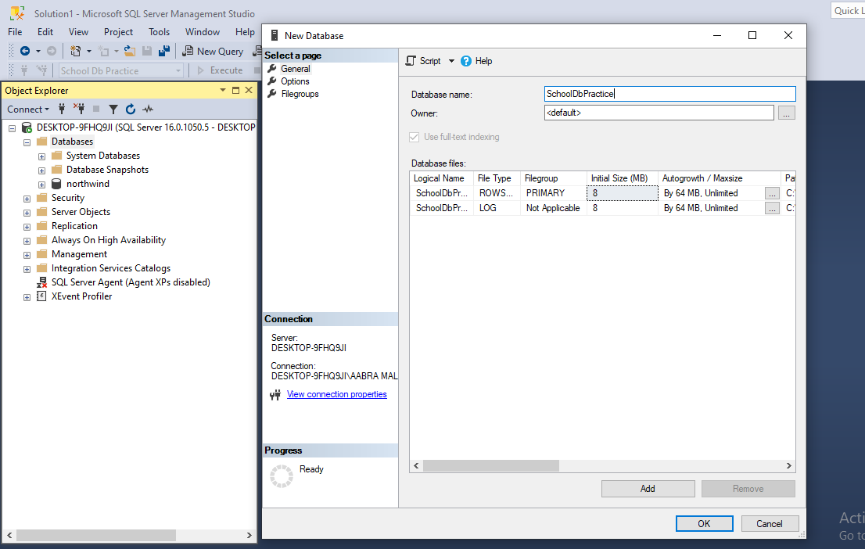

***Student Table Creation***

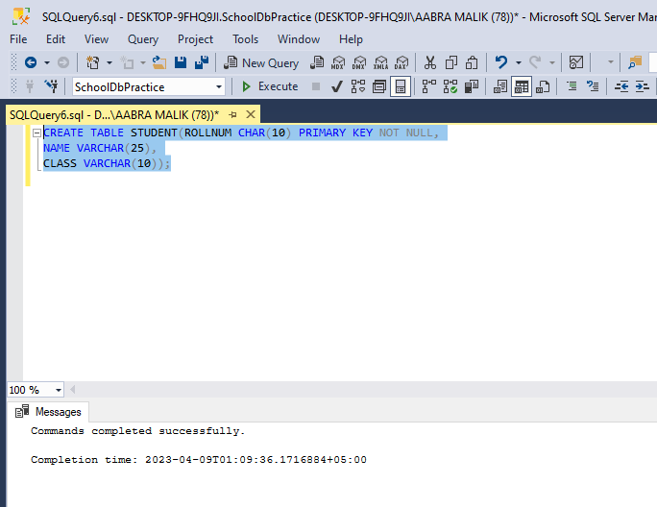

***Teacher Table Creation***

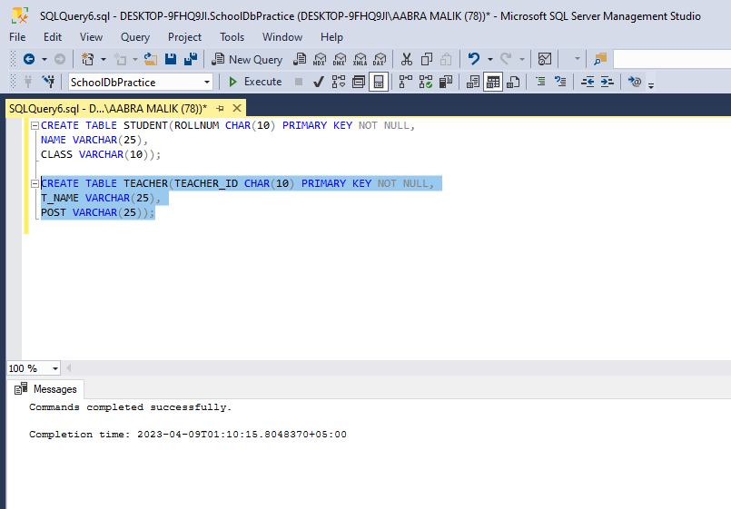

***Inserting Rows in Student Table***

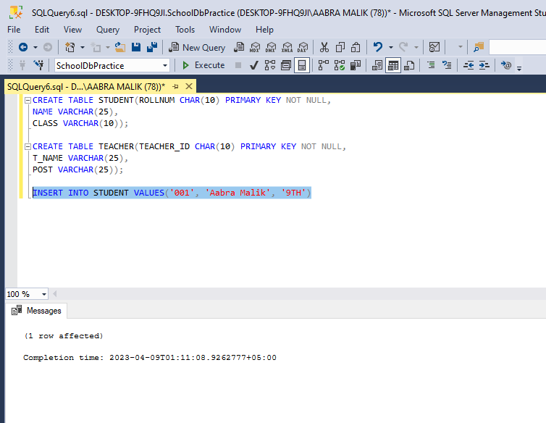

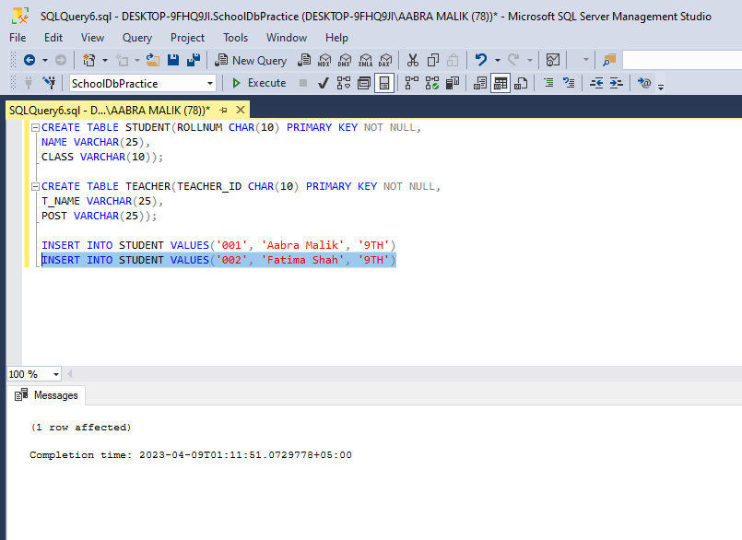

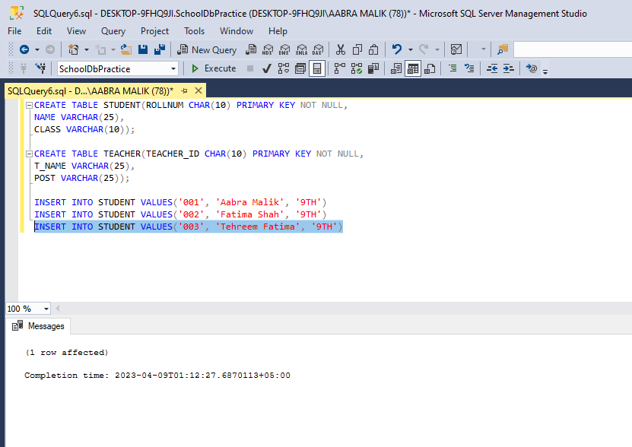

***Inserting rows in Teacher Table***

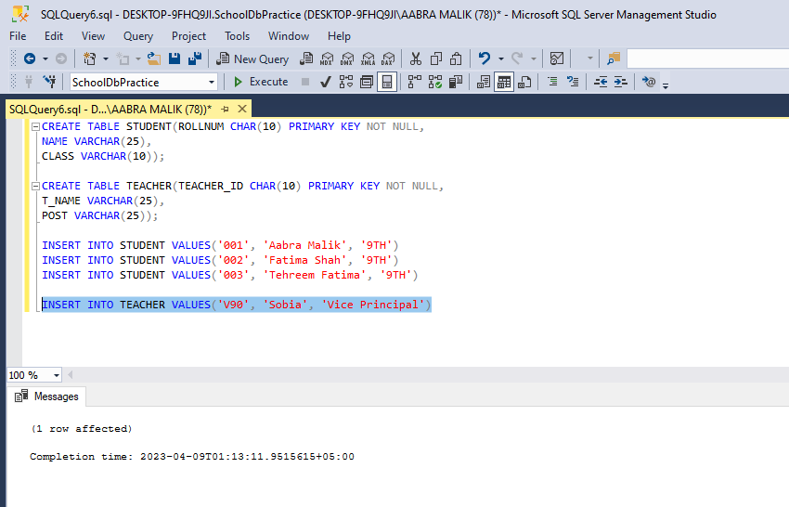

***Viewing Student Table***

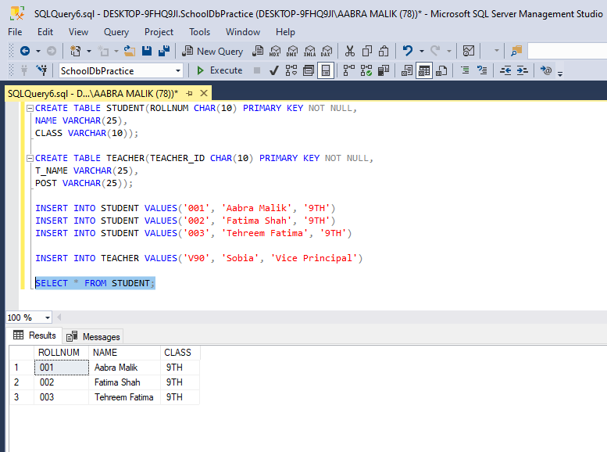

***Viewing Teacher Table***

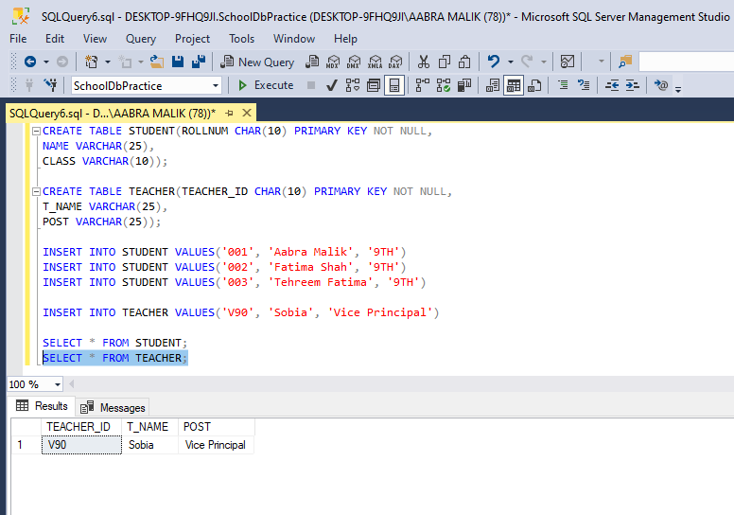

***Altering Database***

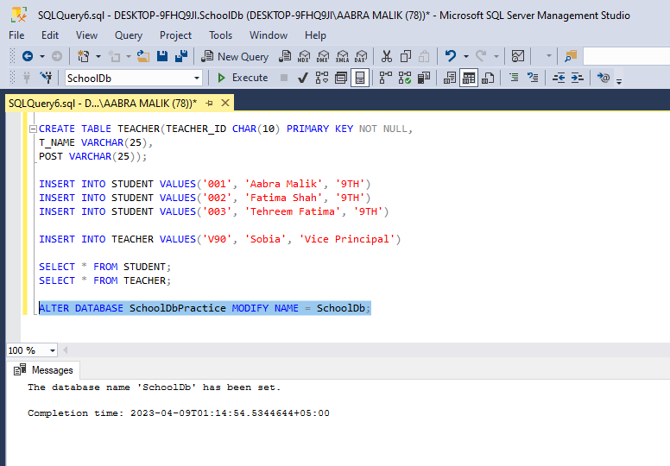

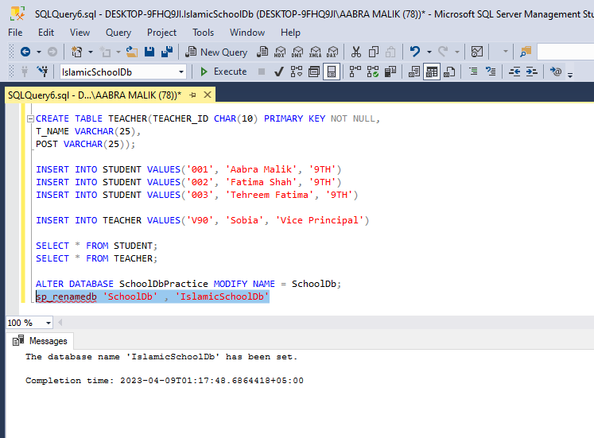

***Deleting the Database***

Query to drop the database



